**STAT 40001/STAT 59800 Statistical Computing Fall 2020**

**Lab-14**

1. The flu season in southern Nevada for 2005–2006 ran from December to April, the coldest months of the year. The Southern Nevada Health District reported the numbers of vaccine-preventable influenza cases shown in Table below.

|  |  |  |  |  |
| --- | --- | --- | --- | --- |
| December 2005 | January 2006 | February 2006 | March 2006 | April 2006 |
| 62 | 84 | 17 | 16 | 21 |

Test whether the numbers of flu cases in the district are equally distributed among the five flu season months. That is, we wish to know if flu cases follow a uniform distribution

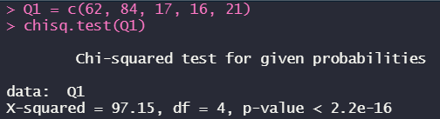

*The p-value above is in favor of the alternative hypothesis that the data doesn’t follow a uniform distribution.*

1. Table below provides data on the top 5 Olympic medal winners in 2016 Olympic

|  |  |  |  |
| --- | --- | --- | --- |
| Country | Gold | Silver | Bronze |
| United States | 46 | 29 | 29 |
| China | 38 | 27 | 22 |
| Russia | 24 | 25 | 33 |
| Britain | 29 | 17 | 19 |
| Germany | 11 | 19 | 14 |

Display the information by creating stack barplot and side-by-side barplot.

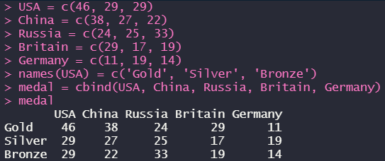

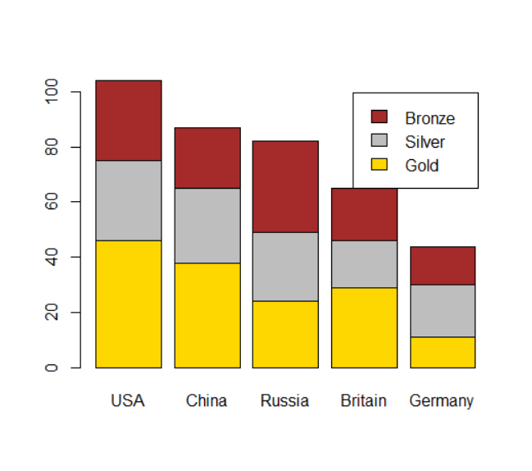

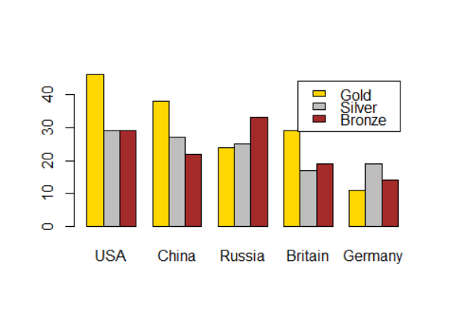

1. Are health and happiness related? The following data represent the level of happiness and level of health for a random sample of individuals from the General Social Survey.

|  | Health | | | | |
| --- | --- | --- | --- | --- | --- |
|  |  | Excellent | Good | Fair | Poor |
| Happiness | Very Happy | 271 | 261 | 82 | 20 |
| Pretty Happy | 247 | 567 | 231 | 53 |
| Not Too Happy | 33 | 103 | 92 | 36 |

Does the evidence suggest that health and happiness are related? Use the *α*=0.05  level of significance.

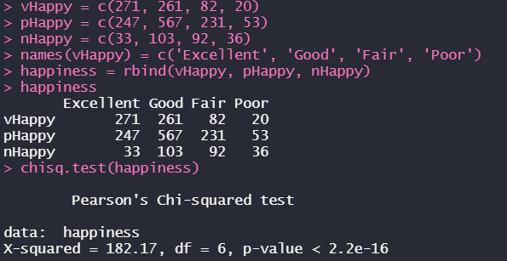  
*We have strong evidence to reject the Null Hypothesis that they are independent and to say that health and happiness are related.*

|  |  |  |
| --- | --- | --- |
|  | Child | |
| Parent | Buckled | Unbuckled |
| Buckled | 56 | 8 |
| Unbuckled | 2 | 16 |

1. An informal survey of seat-belt usage in California examined the relationship between a parent’s uses of a seat-belt with a child’s. The data are provided below

Does the fact that a parent has seatbelt buckled affect the chance that the child’s seat belt will be buckled?

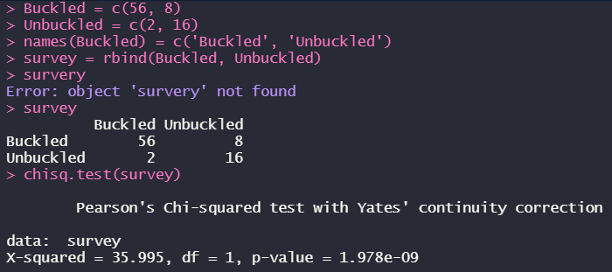  
*We can reject the Null Hypothesis and say that parent’s seatbelt buckled will affect the chance that the child’s seat belt will be buckled, since they are dependent.*

1. A package of M&M candies is filled from batches that contain a specified percentage of each of six colors. These percentage are given in mandms dataset in UsingR package. Assume a package of candies contains the following color distribution: 15 blue, 34 brown, 7 green, 19 orange, 29 red, and 24 yellow. Perform a chi-squared test with the null hypothesis that the candies are from *milkchocolate* group (category).

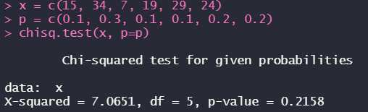

*From the p-value we can’t reject the null hypothesis since that the candies are from milkchocolate group.*

1. Repeat (5) assuming the Peanut Package. Based on the p-value which would you suspect is the true source of candies?

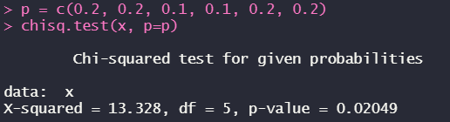

*p-value is less than the significance level which means that we don’t have enough evidence to support the null hypothesis that the candies are from the Peanut Package.*